**eagle-I Post-OBI Workshop Summary**

1. **SERVICES**

1. **Design Pattern Decisions**

A. Services are planned processes. However, rather than making services subclasses of their related planned process as was previously proposed, they will be linked by a *has_part* relation to a related technique or planned process. The reasoning for this is that services have processual parts in addition to a single technique or planned process (such as a billing process, or an order placement process). Modeling services as having related techniques as parts will allow these additional processes included in services to be captured when desired.

* a 'service' is a ‘planned process’ and *has_part* some 'planned process' and *realizes* some 'service provider role' and realizes some 'service consumer role'
* 'service provider role' and 'service consumer role' *inheres_in* some ('homo sapiens' or organization)

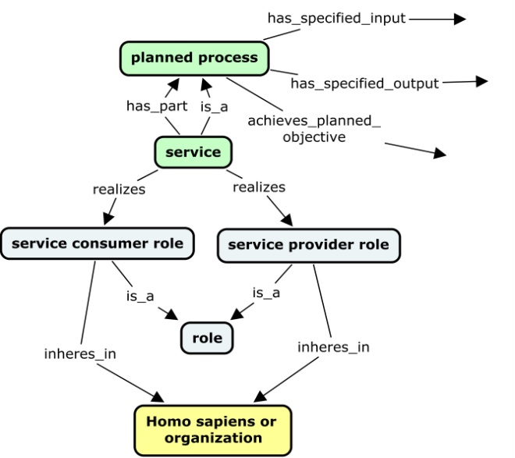

An example of DNA Sequencing Service will look as follows:

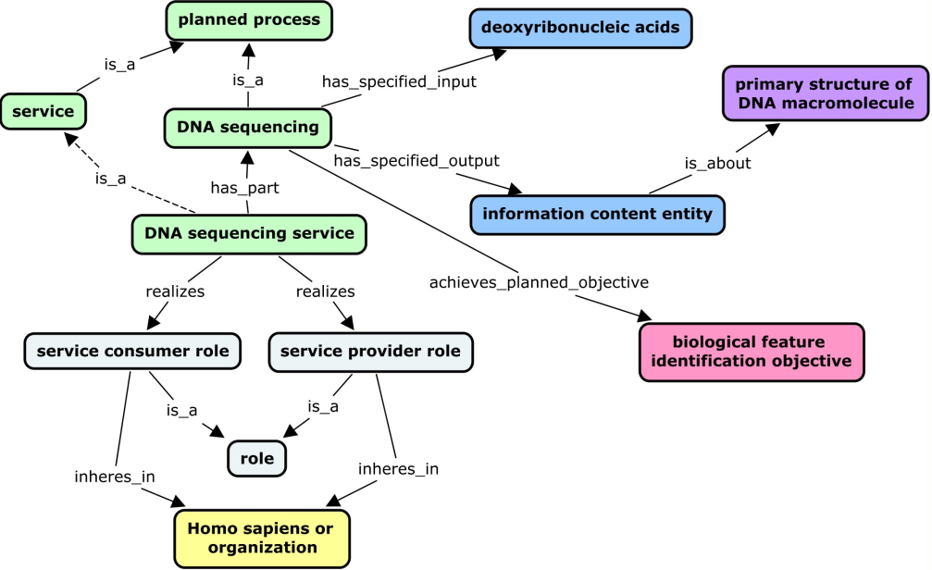

B. An asserted service hierarchy will be built under 'planned process'>'service' to capture services, and axioms attached that define services in relation to other planned processes/techniques, roles, etc.

1. **Service Hierarchy Decisions**

* 1. **OBI Service Hierarchy**

Two principles for classification were discussed :

* 1. A **process-based approach** that uses the nature of the process performed by the service (analysis, production, storage, etc);
  2. An **input/output-based approach** that relies on the nature of the input and output of the service (material vs data).

We decided that classifying services first according to their input/output was more intuitive and useful, and that the type of process performed would be a secondary axis for classification. Thus, the following preliminary hierarchy was proposed (examples in red, definitions in italics)

**Service**

**Access Service** *(def: access provided to a resource -material entity or data or software - for a limited time)*

**Materials Service** *(def: material is input OR output of the service)*

Material Analysis Service (DNA sequencing, cell cycle analysis)

Material Processing Service

Material Production Service (cell line creation)

Material Modification Service (cell line immortalization)

Material Maintenance Service (model organism colony maintenance)

Material Storage Service (liquid nitrogen storage service)

Material Transport Service (chemical disposal service)

**Data Service** *(def: data is input AND output of the service)*

Data Analysis/Transformation Service (statistical analysis service)

Data Maintenance Service (database management)

Data Storage Service (data backup service)

**Training Service**

**Support Service**

Note that this hierarchy is a work in progress, particularly with respect to treatment of the terms 'processing', 'production', 'modification', and 'maintenance' (how these terms relate to each other, how they are defined, etc.)

Carlo and Matt will implement this hierarchy in OBI starting from the 6 top level classes. Probably not for this upcoming April release but for the next OBI release)

1. **SHORTCUT RELATIONS**

We discussed briefly some eagle-i specific needs of simplified relations in particular (see shortcut relations slides on SVN). We decided to start implementing the *provides_service* relations (domain: ‘organization’, range: ‘service’) in a similar way of *achieve_planned_objective*.

Specifically:

a) We will create a ‘service provider’ class equivalent to (organization or 'Homo sapiens')and *(bearer_of* some 'service provider role'*)*

b) We will create the *provides_service* object property with domain ‘service provider’ and range ‘service’.

c) We will then use this shortcut relation consistently to identify the relation between ‘service’ and ‘service provider’.

This would just leave out the information about which planned process realizes the service provider role, which can be derived by the planned process part of service definition.

1. **REAGENTS**

We briefly presented the work that has been done in eagle-i about reagents and discussed where they should live.

**Antibody**

Home: OBI should not be the primary place for these to live. This will require community coordination. Melissa and Matt will work together with Bjoern and Anita on this.

Status in OBI: Currently in OBI as 'material entity' > 'protein complex' > immunoglobulin complex, circulating (antibody).

**Cell Line**

Home: Not clear where these should live. Outsource if there is a good cell line ontology where these could live. But no good one out there that we are aware of. It was believed that cell lines were once in the cell ontology, but we think they may be getting rid of these because they should live in OBI or in some ontology dedicated to cell lines.

Status in OBI: Currently in OBI as 'material entity' > 'cell culture' > 'cell line culture'. Should remain here or perhaps be imported/asserted as a 'processed material’

**Chemical Reagent**

Home: should live in ChEBI

Status in OBI: Closest class currently in OBI is 'material entity' > 'molecular entity'. The eagle-i hierarchy of chemical types may best fit here - then we can classify/place existing laundry list of specific molecular entities currently in OBI within this hierarchy.

**Construct**

Home: These should live in OBI.

Status in OBI: corresponding classes in OBI exist in two places : (1) 'material entity' > 'cloning vector' and (2) 'material entity' > 'molecular entity' > macromolecule > nucleic acid > deoxyribonucleic acid > double-stranded DNA > plasmid > cloning plasmid. We propose to assert construct classes from eagle-i as children of double-stranded DNA, and infer them to be 'reagents' when they are indicated to *have_*role 'reagent role', and/or infer them to be 'processed materials' when they are the *specified_output_of* some 'material processing' process.

**Nucleic Acid Reagent**

Home: Those constructed specifically for experimental use should live in OBI (primer, probe, etc that are manufactured/processed materials for use in experiments). But others may live elsewhere, such as the Sequence Ontology (RNA oligo, for example. BAC or BAC library?)

Status in OBI: Currently seen as 'material entity' > 'molecular entity' > macromolecule > nucleic acid. Hierarchy of nucleic acid reagents (form eagle-i) can be built here (with some classes imported from SO or ChEBI, and others native to OBI).

**Protein reagent**

Home: should live in the Protein Ontology (PRO) when they represent naturally occurring proteins. However, recombinant proteins, fusions, etc. might live in OBI?

Status in OBI: Currently live as 'material entity' > 'molecular entity' > macromolecule > peptide. Peptide has two children : (i) 'protein', which would seem a proper place to subsume naturally occurring proteins imported from PRO; and (ii) 'synthetic peptide' which could subsume non-natural recombinant proteins representing reagents, as defined/modeled in eagle-I (depends on how this class is defined, and how 'synthesis' and 'synthetic' are to be understood . . . are recombinant proteins produced in bacteria 'synthetic'?)

* Would any recombinant peptide/protein produced in bacteria be considered a processed material?
* What about recombinant/synthetic versions of naturally existing proteins? How to classify these?

**Reagent Libraries**

Home: these should all live in OBI (and atomic parts live in their respective ontologies)

* for example, chemical libraries live in OBI, but individual chemicals that make up libraries should live in ChEBI

Status in OBI: several libraries exist in OBI, as children of 'material entity' (phage display library, cDNA library) or of 'processed material' (paired-end library, screening library). We would propose that all libraries are 'processed materials', in that they are collections created for the purpose of an investigation.